Stock Transfer Request and Confirmation

- Purpose

As soon as the customer was able to settle his account, he may now go to the branch to redeem his previously deposited motorcycle for Stock Transfer Request and Confirmation.

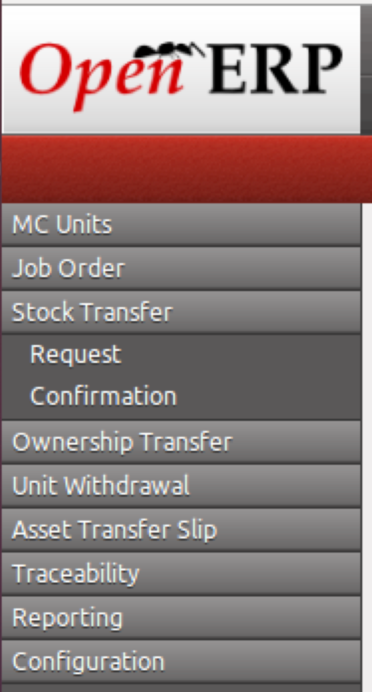
Figure 1. Menu items of Stock Transfer Request and Confirmation

- Views
  - List View
Figure 2. List view of Stock Transfer Request

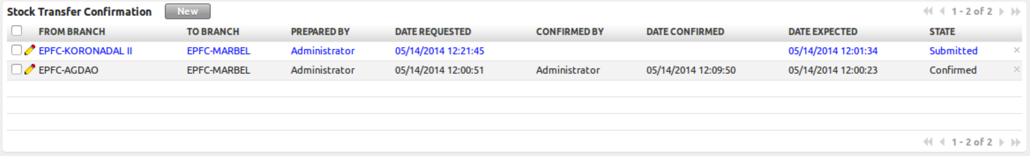
Figure 3. List view of Stock Transfer Confirmation

  - Form View
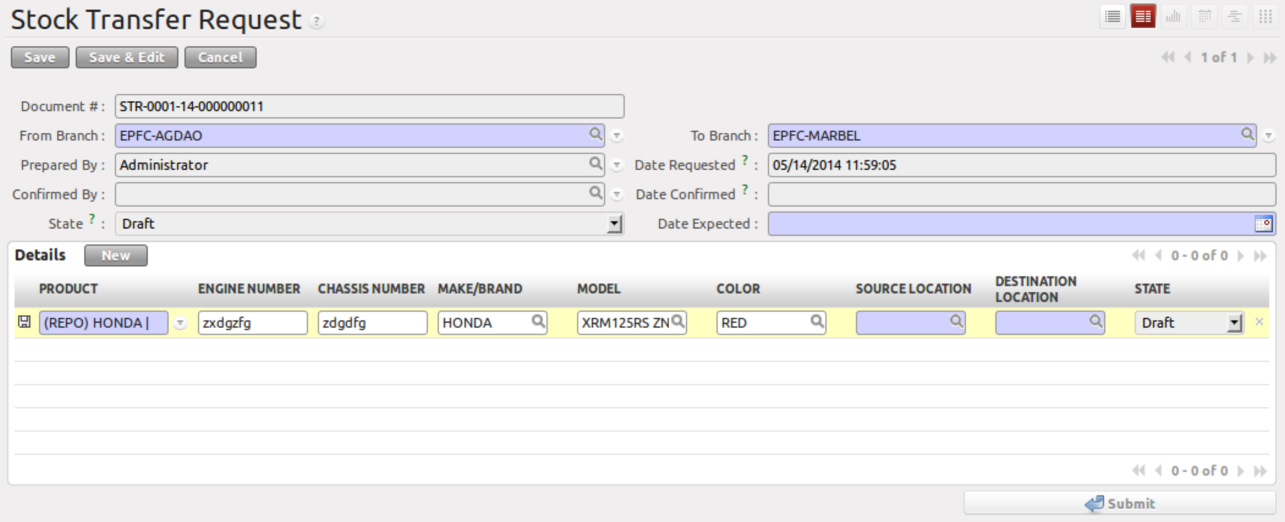
Figure 4. Form view of Stock Transfer Request

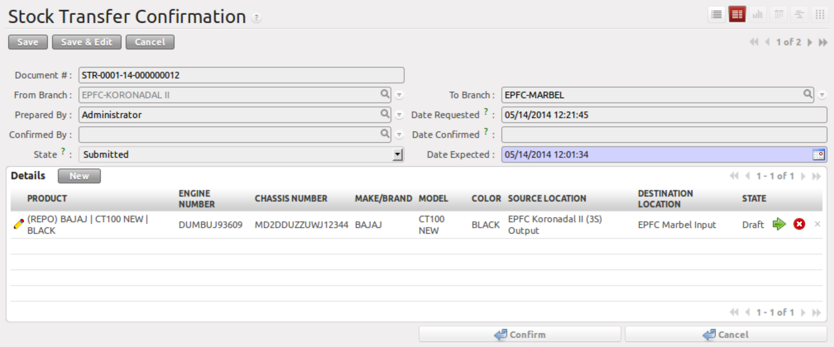
Figure 5. Form view of Stock Transfer Confirmation

- Menu and Access Rights
  - Menu
      - Warehouse > Stock Transfer > Request
      - Warehouse > Stock Transfer > Confirmation

  - Access Rights (TBD)
Role | Read | Write | Create | Delete
Receptionist | Yes | Yes | Yes | No
CI/Collector | Yes | Yes | Yes | No
Branch Manager | Yes | Yes | No | No

- Required Configuration
  - Warehouse > Configuration > Warehouse Management > Warehouse
- Each branch will have one (1) warehouse with three (3) locations:
    - Input – this location will include all incoming products
    - Stock – this location will include all products in the inventory
    - Output – this locaiton will include all products for delivery

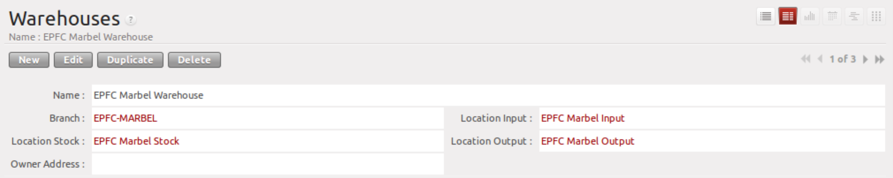
Figure 6. Warehouse Configuration

- Required Fields
All required fields can be easily distinguished from the form view. These are the fields highlighted in Figure 4.

- From Branch – Source branch where the unit will be coming from
- To Branch – Branch where the user belongs to, this is automatically filled up
- Date Expected – Date when the unit will be expected by the requesting branch
- Details – List of units to be transferred; an empty list will cause an error (error code 00088)
- Source Location – automatically set to the Output location of the source branch
- Destination Location – automatically set to the Input location of the requesting or destination branch

- Workflow
Below is the list of states and visibility of the various buttons based on the record state:

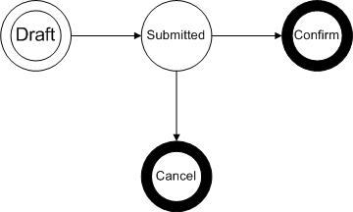
Figure 7. Workflow of Stock Transfer

 | Stock Picking State | stock_move.location_id | stock_move.location_dest_id | Stove Move State
Stock Transfer
Request | draft | from_branch.lot_output_id | to_branch.lot_input_id | draft
Confirmation | confirmed | from_branch.lot_output_id | to_branch.lot_input_id | waiting
Table 1. Stock Move of the workflow

State | Description | Visible Buttons
Draft | Initial state of the record | Submit
Submitted | Record is finalized and ready for confirmation. Once submitted, fields are not editable. | Confirm
Confirm | Record has been confirmed and will be seen from Warehouse > Ownership Tranfer > Transfer Slip  Stock move will be set to ‘waiting’ state | None
* for finalization

- User Action
Below is the list of user action available for specific users and its corresponding procedures:

Button | Action | Triggred By
Submit | Record will be changed to ‘Submitted’ state and will be seen under Warehouse > Stock Transfer > Confirmation | Receptionist  CI/Collector
Confirm | Record has been confirmed and will be seen from Warehouse > Ownership Tranfer > Transfer Slip  Stock move will be set to ‘waiting’ state | Branch Manager of requesting or destination branch (‘To Branch’)

- Field Visibility
All fields are visible in all states.

- Reports and Print Outs
